Model Input Format :
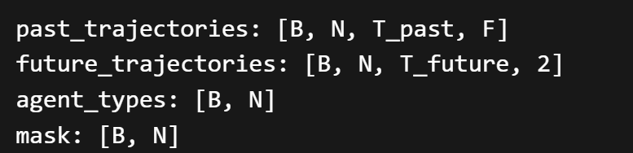
B → Batch size
Number of scenes per batch
N → Number of agents in a scene
T_past → Past timesteps
2 seconds → ~5–10 timesteps

T_future → Future timesteps
3 seconds → ~6–15 timesteps

F → Features per timestep
[x, y, vx, vy, heading, ax, ay]

Agent Types -
encoding -
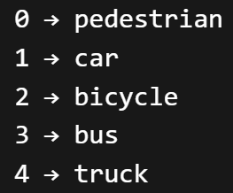
Mask –
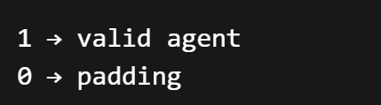
Graph Input-
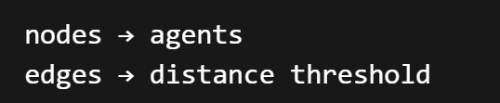

Input flow :
